SPORT INTERVIEWS
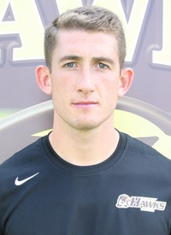
Tom Owens
Graduate Assistant
owensth@quincy.edu

Tom Owens, originally from Liverpool, England, is currently the Graduate Assistant at Quincy University Men’s Soccer team. Prior to joining the hawks, he played his collegiate soccer at Notre Dame College in Ohio. In addition to that, he has captained the Michigan Bucks PDL soccer team to two National Championships in the past three years. As well as, being a student athlete, Tom coached u12 boy’s club soccer during his time at Notre Dame.

Tom is in his second year as a grad assistant, last year they had a 9-5-3 record and currently are sitting third in their division with a record of 8-4-2. Tom expressed how he is a hands on type of coach and thinks he can relate to the modern day student athlete just because he was recently one himself.

During my interview with Tom, he stressed how important it was for me to reach out to schools that I’m interested in as soon as possible. He went on to say, that he had left it as late as July to get sorted and he was fortunate to be in the position that he’s in today, only because of the connections he had made over time.

SPORT INTERVIEWS
Jimmy Walker
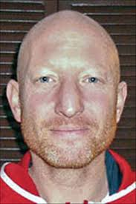
Executive Director of Coaching
JImmywalker82000@yahoo.com

Jimmy Walker, who originates from Birmingham, England, is currently the Executive Director of Coaching at pacesetter soccer club. He played his collegiate soccer at Tiffin University where he was an All-American and got drafted to play in the MLS. Unfortunately for him, things didn’t work out due to visa issues. He went on to be a grad assistant and head coach at Tiffin University. Soon after, he took the opportunity to be the head coach at Penn State University Women’s Soccer, which he truly enjoyed.

Since joining Pacesetter Soccer Club, Jimmy has transformed the club for the better. Today, they have six-teen age groups, with three teams per age group, as well as, their U17, U18 and U19 academy teams. In addition to that, Jimmy has helped develop sponsors who have facilitated the funds to maintain their two outdoor soccer fields and one indoor field. Furthermore, since jimmy’s arrival there has been a sufficient increase in soccer scholarships earned by Pacesetter players.

Jimmy had said, experience a great thing to have, so I would advise doing lots of voluntary coaching with kids of all ages; this will give you a good feel for coaching different ages and skill levels. Reach out to friends at different colleges, they often will put in a good word for you, or will hear about employment opportunities before they’re put online.

SPORT INTERVIEWS
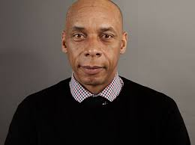
Peter Smith
Director & FA Intermediary
petesmith@newera.com

Peter is a former professional footballer, having played with Brighton for 6 years as a Right Back. His footballing career started whilst studying at Greenwich University when he was given the opportunity of joining the team by the Manager of Brighton at the time, Liam Brady. In 2000 he returned to Greenwich University where he gained his Diploma in Sports Management.
Having built a strong relationship with The Professional Football Association whilst playing, CEO, Gordon Taylor offered Peter a full time position based in their London headquarters. Peter executed a number of roles for the Union from dispute and resolution issues to representation of players. It was during this time that he also became licensed as an Agent by the FA and developed as a Commercial Guru, using his unique ability to think outside of the box. Today, Peter is the Director & FA Intermediary at New Era Global Sports.

Peter and New Era, have been responsible for some of the largest transfer deals known to English football. Peter played and still acts as an agent, so he knows the ins and outs of negotiation game.

Pete thinks it would be very helpful if I had a good playing career, where I would not only meet but gain the trust of important connections. However, it would not be essential, he advised me to take my FA agent badges as soon as I graduated to get the ball rolling.

